Upgrading Your Mac to Monterey

This document explains how you can upgrade your Mac operating system to Monterey using JAMF Self Service.

- Before upgrading, please ensure you have a backup of all your work and your Mac is connected to a power source.

- If you are off campus, please ensure you are connected to our VPN service before running the upgrade.

- Please note, we cannot offer this service currently to M1 based Macs.

Run the Self Service app. This can be found in /Applications on your Mac hard drive. Typing “self” into spotlight search will also display it.

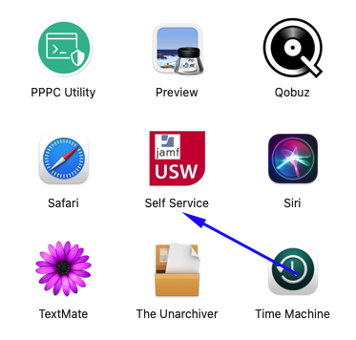

Login using your UNI domain credentials.

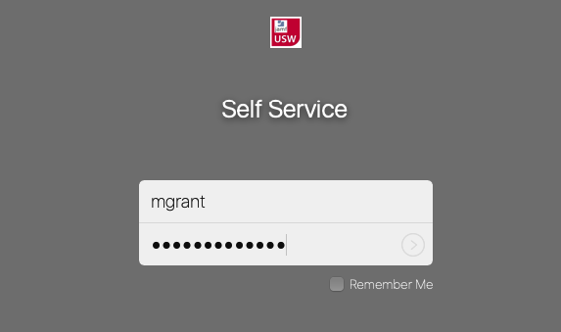
In Self Service, the Monterey upgrade can be found in the OS Maintenance and Upgrade Tab as shown below:

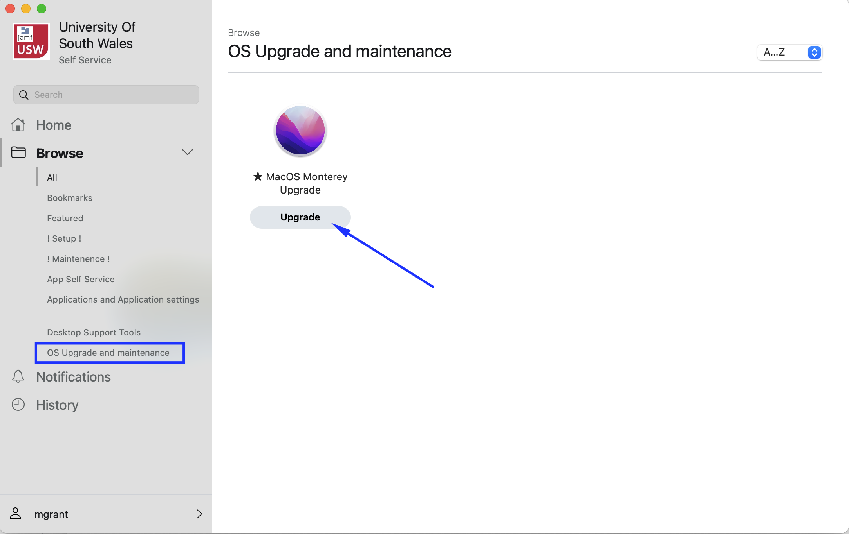

Before clicking Upgrade, please read the warning message and ensure no applications are running. Your mac will need to be connected to a power source and running the VPN service.

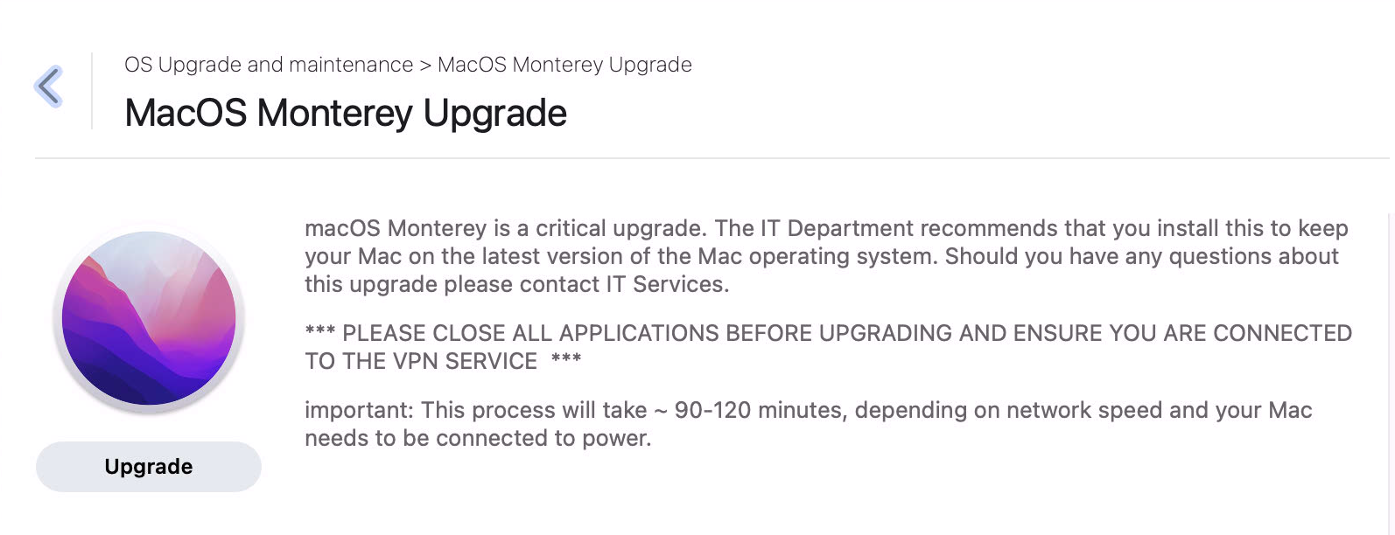

After clicking Upgrade you will see the following message. Your Mac will reboot once the upgrade is ready to install.

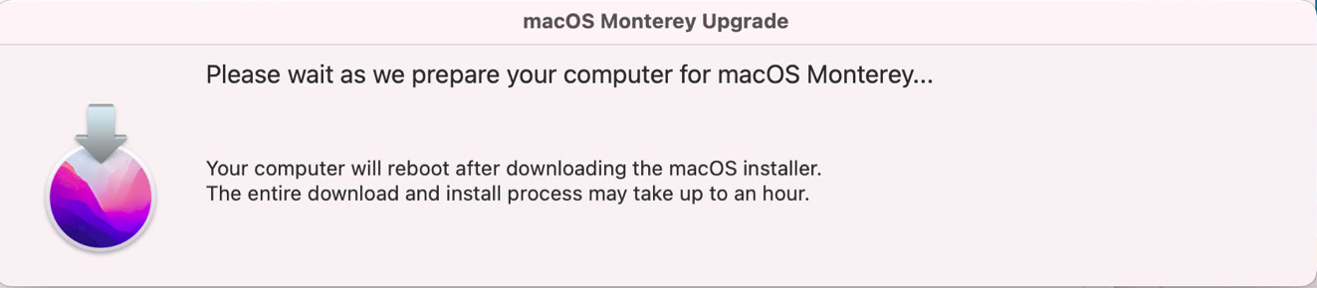

When the machine reboots the upgrade will then take place. A progress bar will appear as below with an estimated time to completion.

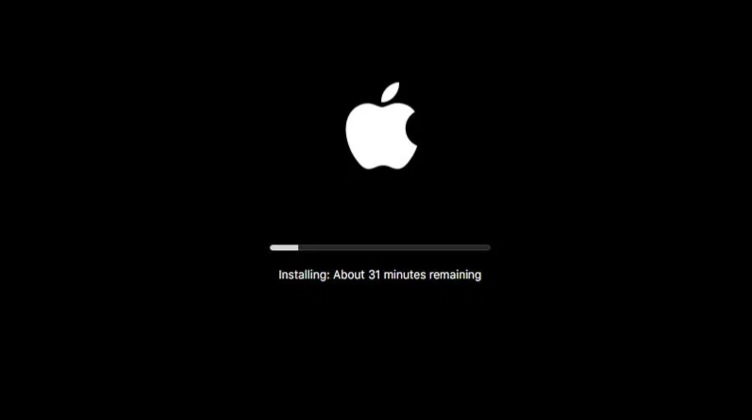

Once complete you can log into your Mac as normal.

