Upgrading your Mac to Big Sur

This document explains how you can use JAMF to upgrade your Mac operating system to Big Sur using JAMF Self Service.

- Before upgrading, please ensure you have a backup of all your work and your Mac is connected to a power source

- If you are off campus, please ensure you are connected to our VPN service before running the upgrade.

Run the Self Service app on your Mac, this can be found in /Applications on your Mac

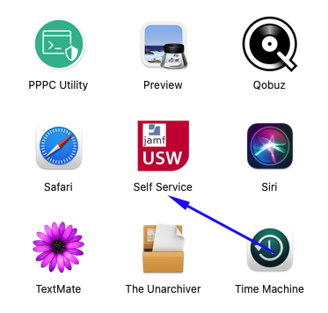

Login using your UNI domain credentials

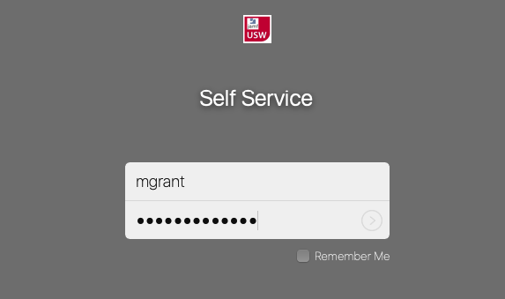
In Self Service, the Big Sur upgrade can be found in the OS Maintenance and Upgrade Tab as shown below:

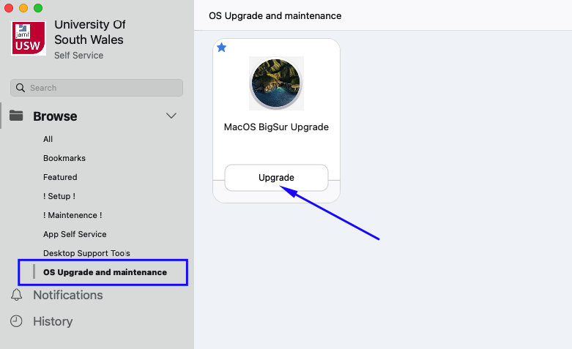

Before clicking upgrade, please read the warning message. Ideally your mac will need to be connected to a power source to ensure your battery doesn’t run out during the process.

