Release of enhanced security feature in email

As part of our continued security programme we are updating our current protection quarantine procedures for staff and extending this functionality and new system to students too.

We are enabling enhanced protection and self-service quarantine services. This means that if you receive a message that Microsoft believes is potentially harmful to either you or the institution, it will be added into a quarantine space pending your review. In almost all cases these messages can be ignored. However, every 3 days you will receive a summary email of new quarantined items within that time period. If any of the items appears to be interesting you can click review, alternatively you can block the sender directly from the email. This service better protects you and is more convenient as it removes the requirement of contacting IT to release messages on your behalf.

In addition, this new system provides improved spam email filtering so all users should see a reduction in SPAM being received into inboxes. We do suggest that you monitor the Junk folder for a week or so after implementation to ensure that any ‘approved’ senders are not being inadvertently redirected to the Junk folder – this setting can be easily adjusted by marking it accordingly in the system if discovered (please see guidance tutorial video below).

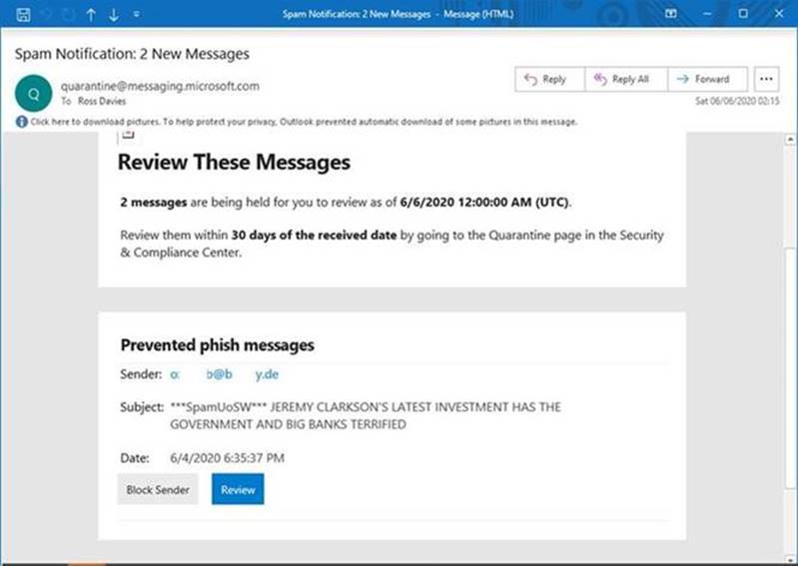

Once you have clicked on review you will be taken to the quarantine area in office 365, from here click on the appropriate message: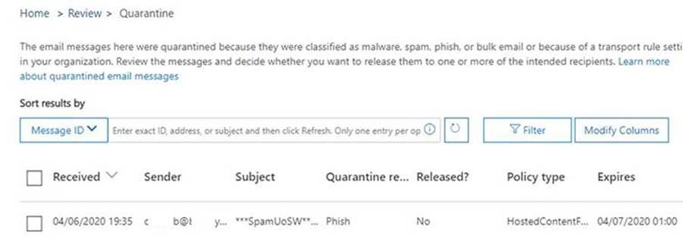

We recommend you should always click **preview message** prior to deciding to release: 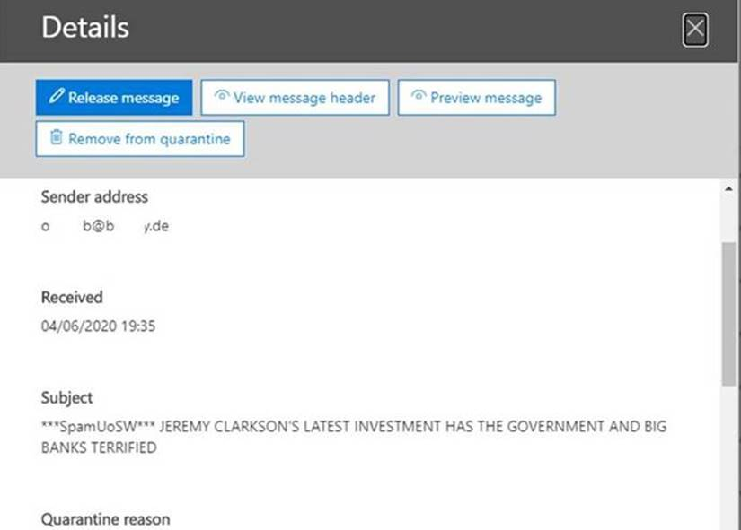

A preview can then easily be viewed prior to deciding the next action: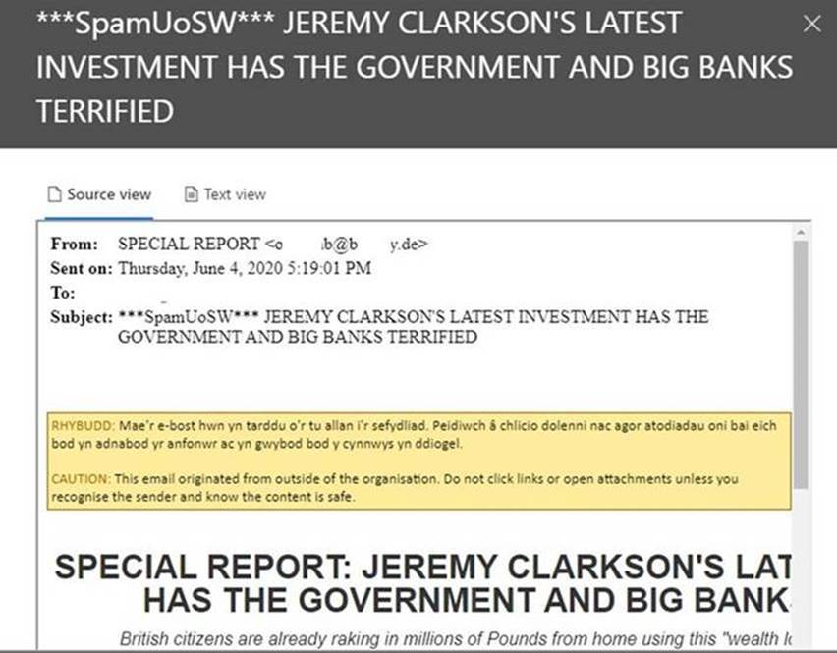

In the event you decide you want the message click **Release Message**, you then can decide to turn off reporting to Microsoft prior to confirming by clicking **Release Message** again: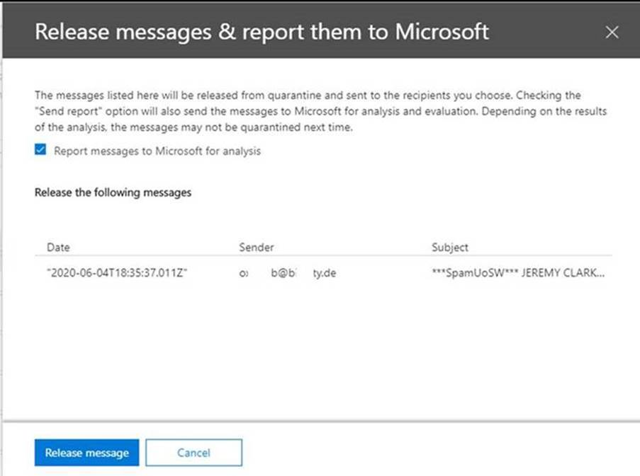

You should then see confirmation and the message should be delieved as expected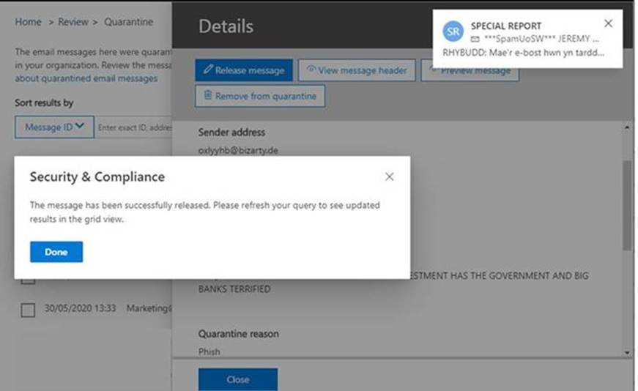

You can also permanently delete the message by clicking **Remove from quarantine**, and then **Yes**: