Instructions on how to install eduroamCat on an Android Phone

- On the phone, browse to Google Play Store or Amazon Appstore and search for “eduroam CAT” select and install the app.  Before opening the app if you have an existing eduroam Wi-Fi profile go to your network settings and “forget” the existing eduroam network.  To do this;  - Tap at the top of screen and drag down to view the control panel.  - Tap and hold the wifi logo to view a list of available networks  - Tap and hold the Eduroam wifi option  - Tap “Forget network” | 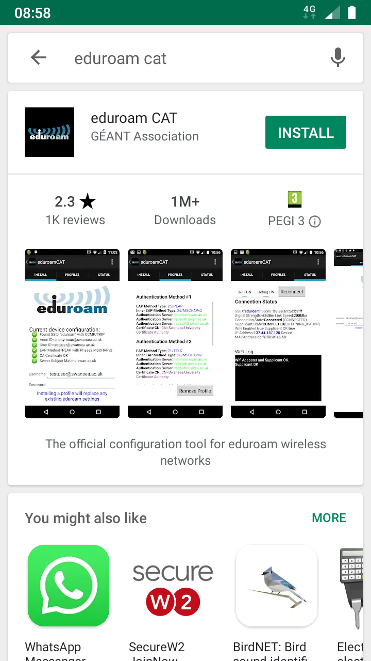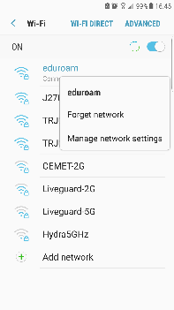
- Once installed, open the eduroam CAT app and wait for the list of “Nearby Configs” to load and display all of the organisation logos. | 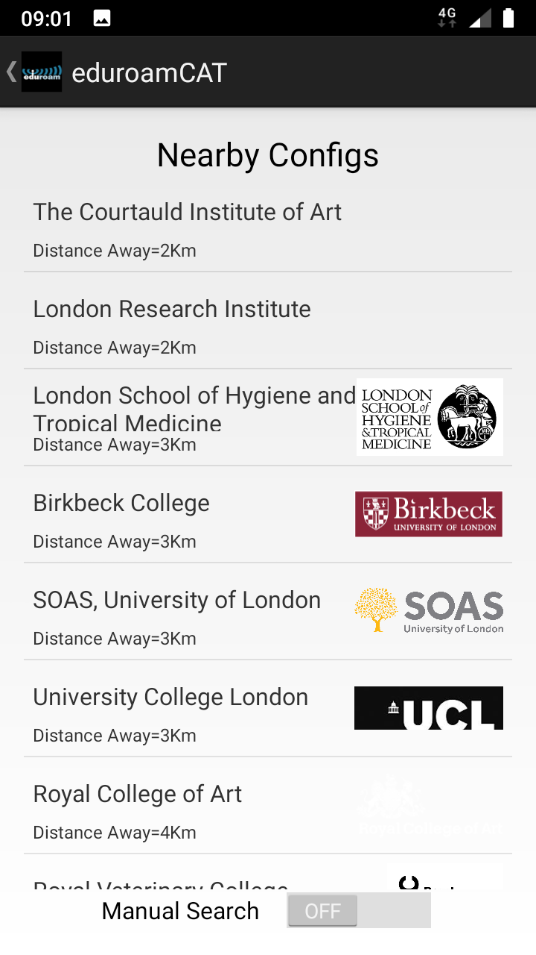
- If the University of South Wales is not on the first page of available configs;  - Turn on “Manual Search”  - Type in “university of south wales” and tap search. | 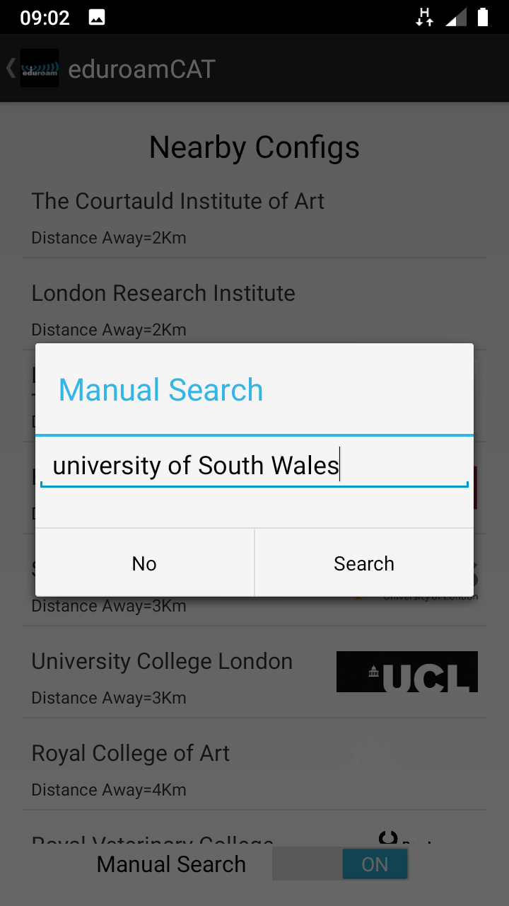
- If you do see the config for University of South Wales;  - Tap it and proceed to step 10.  If you do not see a config for University of South Wales;  - Please continue to step 5. | 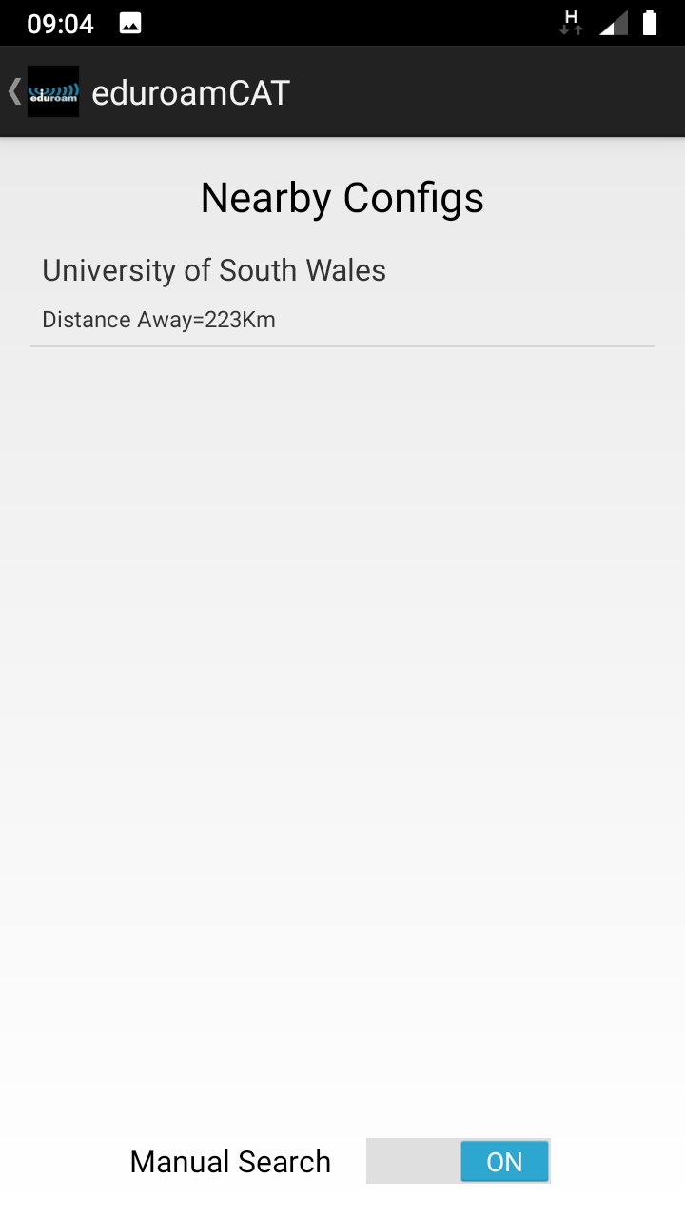
- Visit the eduroam CAT website at https://cat.eduroam.org and tap “Click here to download your eduroam installer”. | 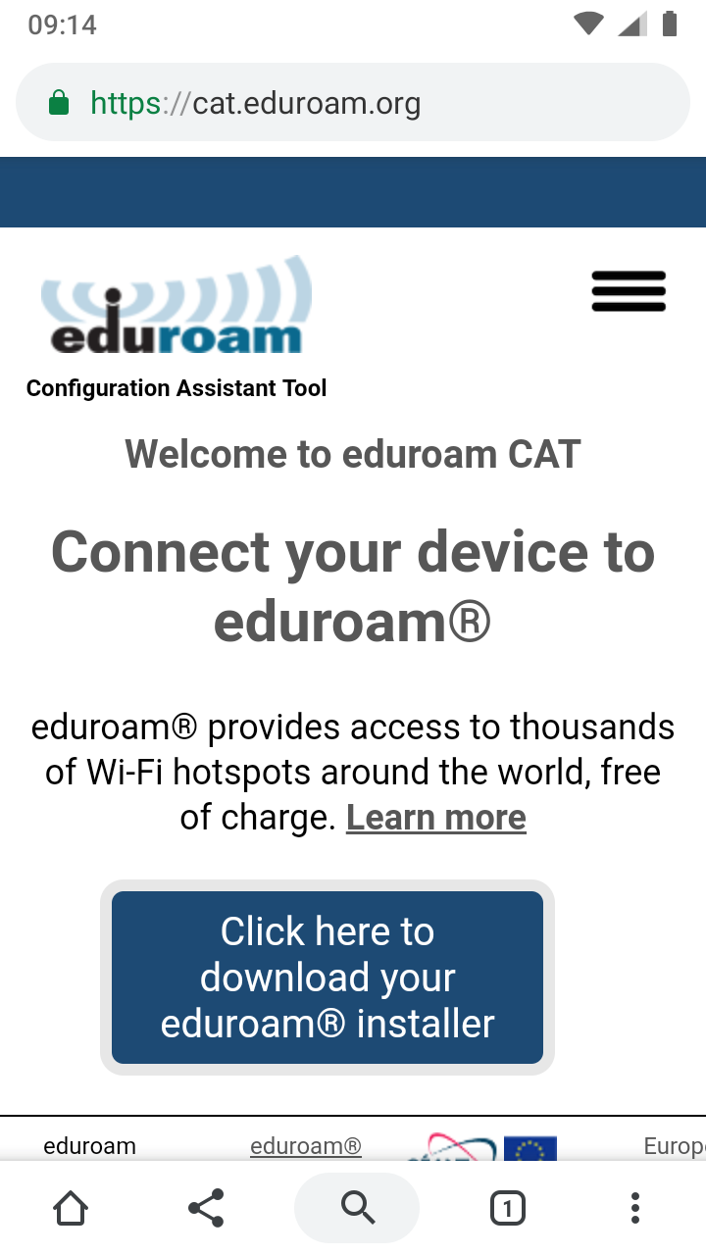
- Type “university of south wales” into the search box.  Tap the “University of South Wales” button. | 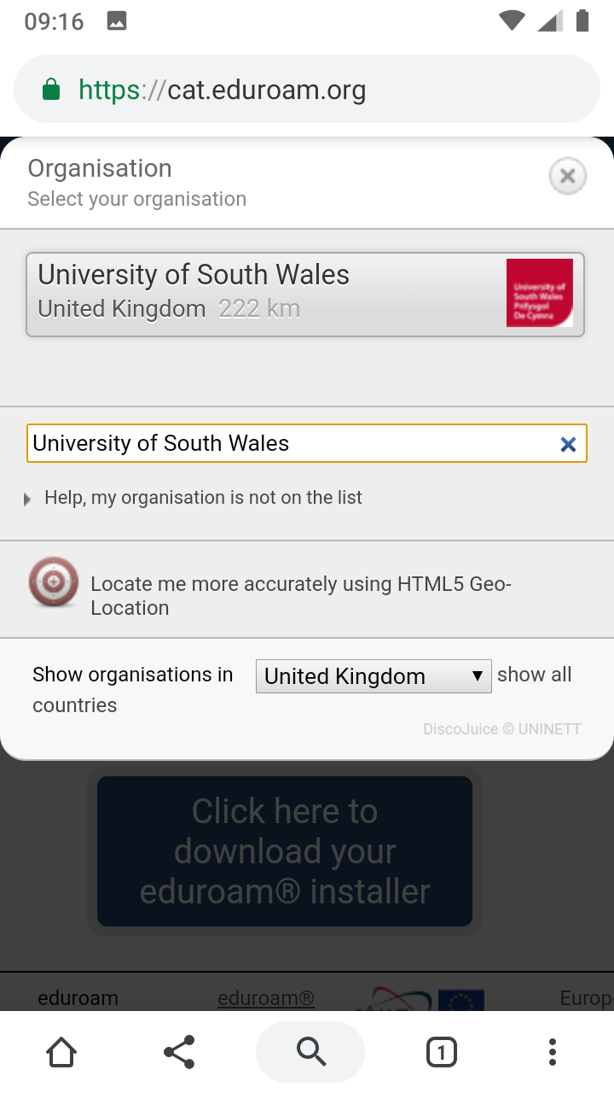
- Confirm and check the organisation details and then click the big blue Android button. | 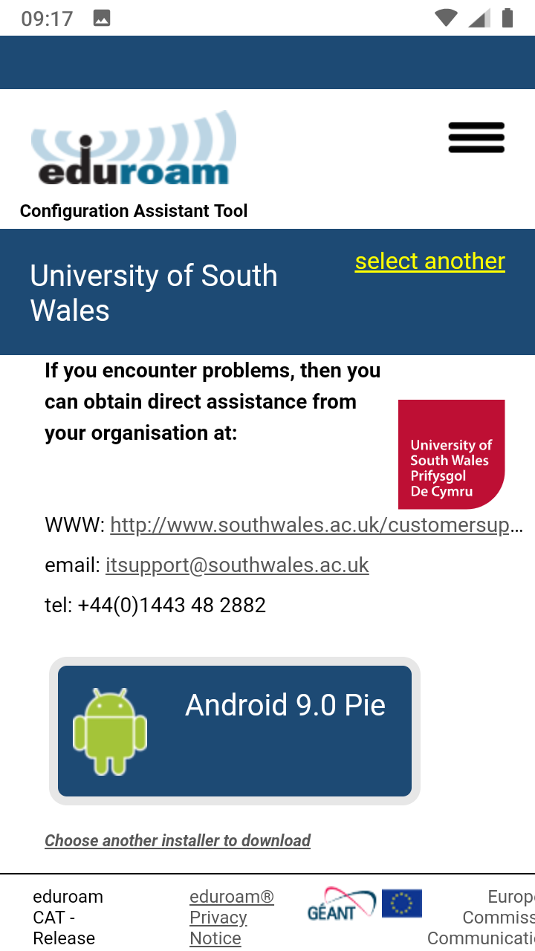
- You are reminded that you must download the eduroam CAT application before proceeding.  You have already done this by following this guide, so tap the “Continue” to download the configuration. | 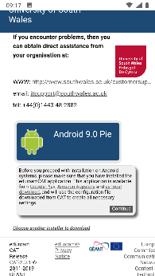
- With the configuration downloaded tap on the “Open” button.  You should be redirected to the eduroam CAT application automatically.  If not go and open the eduroam CAT application manually. | 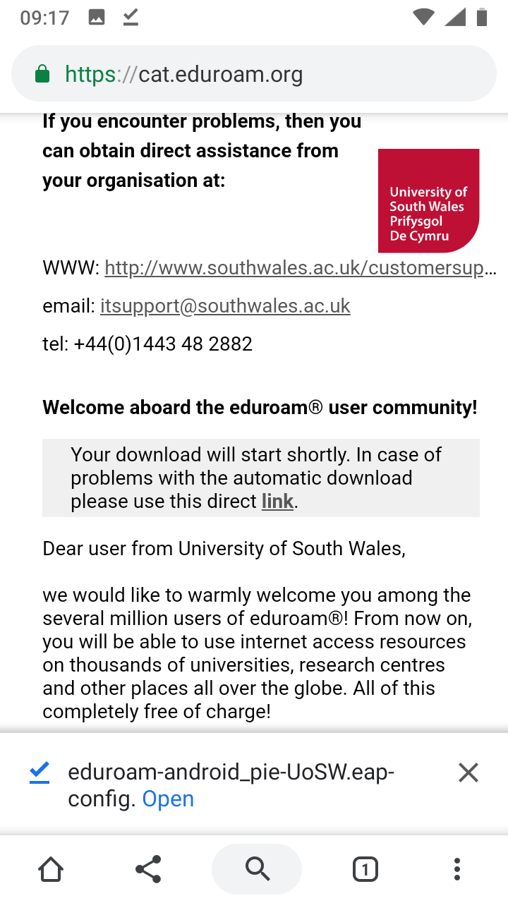

- If you jumped ahead at step 4 this is where you continue.  If prompted, “allow eduroamCAT to access”.  You will now be presented with the Configuration File Summary.  Check to make sure that  - “Authentication Server” is listed as “eduroam-auth.glam.ac.uk”  - “CA Certificate CN” is listed as “QuoVadis Root CA 2”.  If both are correct tap the “Install” button. | 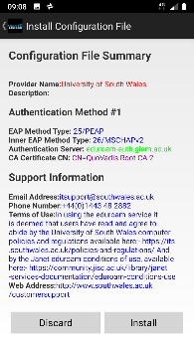
- Read the terms of use and tap “Yes” to install the profile | 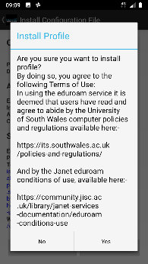
- Enter your Username as follows;  - userID@southwales.ac.uk  (Please note this is NOT actually your email address but your user name, authenticating at the domain of Southwales).  - Enter your Password. This is your normal 12 digit university password.  - Tap “Install” | 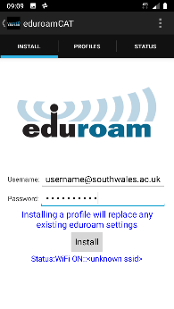
- You should get a confirmation that the eduroam Profile has been installed.  Within a few seconds you should be connected to eduroam.  If necessary go to your Wi-Fi settings and manually connect to the saved eduroam network | 