Instructions on how to install eduroamCat on an Apple iPhone

- On the iPhone, browse to the following web site
http://cat.eduroam.org

- Tap on “Click here to download your eduroam® installer”. | 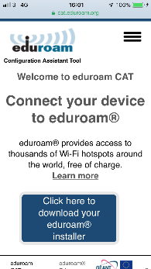
- You will be presented with a list of organisations.  Scroll through the list to find the University of South Wales.  If you cannot find it (or it is not shown), scroll down to the Search box and enter South Wales. | 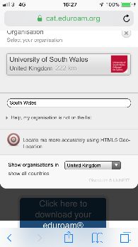
- Tap on the University of South Wales.  Your browser will open another page.  Select Apple iOS mobile devices. | 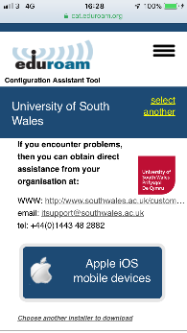
- Tap Allow to download the configuration profile.  A message should state that the Profile has been downloaded, and it can now be reviewed and installed in Settings.  Open your iPhones Settings App. | 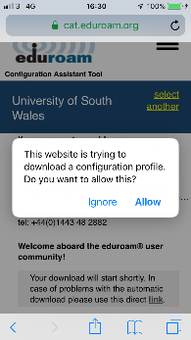
- Go to General, Profile and select the eduroam® downloaded profile. | 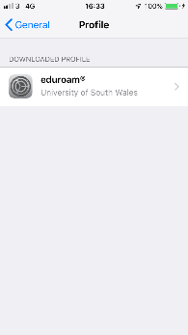
- Confirm and check the Profile details are verified and then tap Install.  You may be asked to enter your iPhone passcode in order to install the Profile.  Read the message from the University of South Wales regarding Consent. Tap Next.  Read the Warning message and then tap install.  Confirm Install | 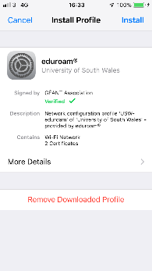
- Enter your Username as follows;

- userID@southwales.ac.uk
(Please note this is NOT actually your email address but your user name, authenticating at the domain of South Wales).

- Tap Next

- Enter your Password. This is your normal 12 digit university password.

- Tap Next

- You should get a confirmation that the eduroam Profile has been installed.  Within a few seconds, you should be connected to eduroam.  If necessary go to your Wi-Fi settings and manually connect to the saved eduroam network | 